**Example 1 - ESTIMATED BOARD COST STANDARD VS ESTIMATED ACTUAL OVERVIEW**

The estimated cost for SBS18 was $975 per Ton which is transferred to the Job Material folder listed below. The standard cost on the job query will use the $975 per Ton to calculate the standard cost.

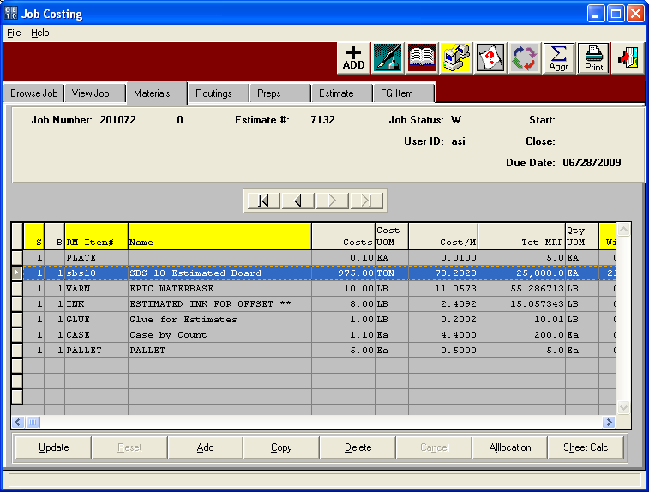

**Example 1 - ESTIMATED BOARD COST STANDARD VS ESTIMATED ACTUAL OVERVIEW**

The standard cost is 25,000 sheets /1000 times (sheet width of 21.75 times sheet length 25.625 / 144) to yield the total 96.76 MSF. The 66.3 basis weight known as weight per MSF for the SBS18 times the 96.76 MSF equals 6415.188 pounds divided by 2000 equals 3.2076 times $975 per ton = $3127.44 which is listed on the job inquiry.

The actual cost is 26,000 sheets /1000 times (sheet width of 21.75 times sheet length 25.625 / 144) to yield the total 100.63 MSF. The 66.3 basis weight known as weight per MSF for the SBS18 times the 100.63 MSF equals 6671 pounds divided by 2000 equals 3.335 times $875 per ton = $2,918.94 which is listed on the job inquiry.

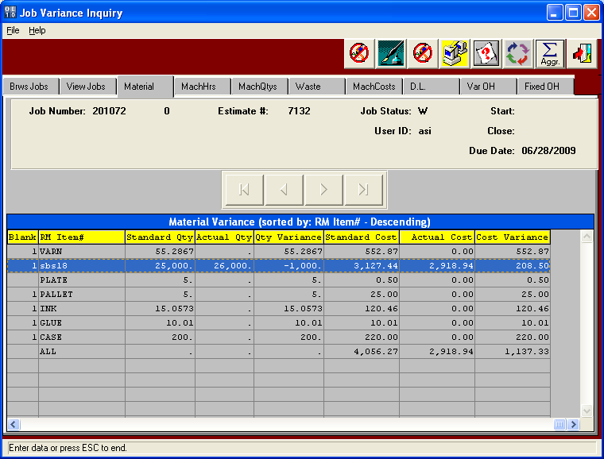

**Example 1 - ESTIMATED BOARD COST STANDARD VS ESTIMATED ACTUAL OVERVIEW**

The actual cost is 26,000 sheets /1000 times (sheet width of 21.75 times sheet length 25.625 / 144) to yield the total 100.63 MSF. The 66.3 basis weight for SBS18 known as weight per MSF for the SBS18 times the 100.63 MSF equals 6671.87 pounds divided by 2000 equals 3.3359 times $875 per ton = $2,918.94 which is listed on the job inquiry.

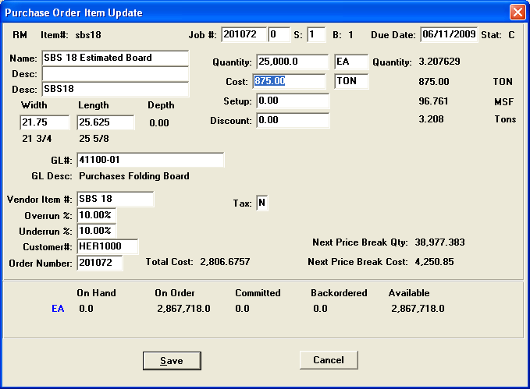

**Example 2 - ESTIMATED BOARD STANDARD COST VS REAL BOARD ACTUAL COST OVERVIEW**

The estimated cost for SBS18 was $975 per Ton which is transferred to the Job Material folder listed below. The standard cost on the job query for real material will use the estimated cost of $975 per Ton and estimated sheet size of 21.75 x 25.625. Therefore, 25,000 sheets on the PO times (21.75 x 25.625 / 144) times 66.30 estimated basis weight = 6415 pounds. Divided by 2000 pounds = 3.207 Tons times $975 per ton = $3,127.44. So the standard cost per sheet in the job file is $3,127.44 / 25,000 sheets = .12509 Each Sheet. Please note, this standard cost per sheet is not used to calculate the real boards actual cost.

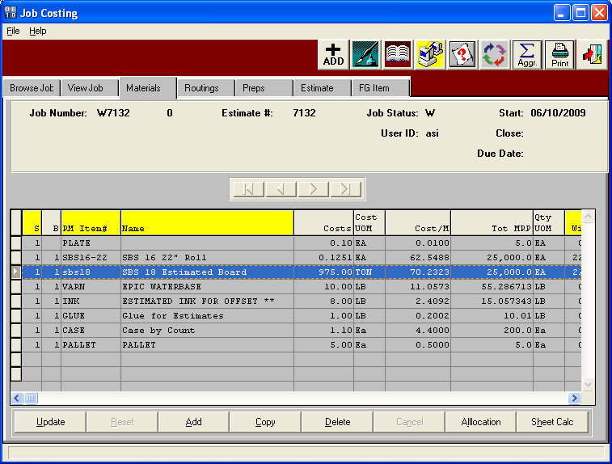

**Example 2 - ESTIMATED BOARD STANDARD COST VS REAL BOARD ACTUAL COST OVERVIEW**

The standard cost is 25,000 sheets /1000 times (sheet width of 21.75 times sheet length 25.625 / 144) to yield the total 96.76 MSF. The 66.3 basis weight known as weight per MSF for the SBS18 times the 96.76 MSF equals 6415.188 pounds divided by 2000 equals 3.2076 times $975 per ton = $3127.44 which is listed on the job inquiry.

The actual cost is the raw material receipt for SBS16-22 Real Board cost is 26,000 sheets /1000 times (sheet size of 22 x 25.625 / 144) to yield the total 101.788 MSF times $50 per MSF = $5,089.42 which is listed on the receipt screen.

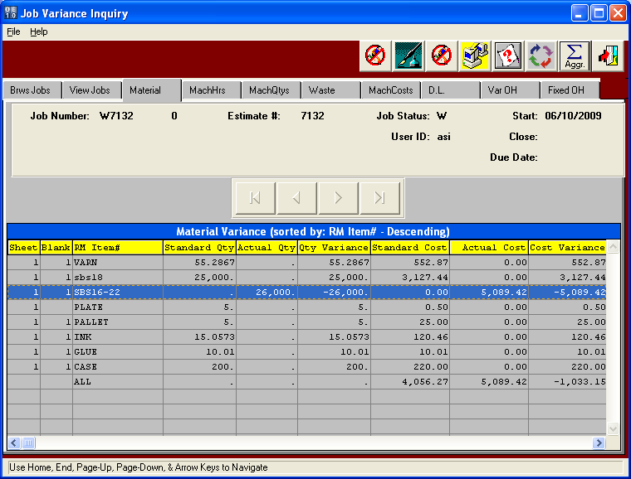

**Example 2 - ESTIMATED BOARD STANDARD COST VS REAL BOARD ACTUAL COST OVERVIEW**

The purchase order for SBS16-22 Real Board cost for 25,000 sheets /1000 times (sheet width of 22 times sheet length 25.625 / 144) to yield the total 97.873 MSF times $50 per MSF = $4,893.66 divided by 25,000 sheets equals .195746 EACH cost.

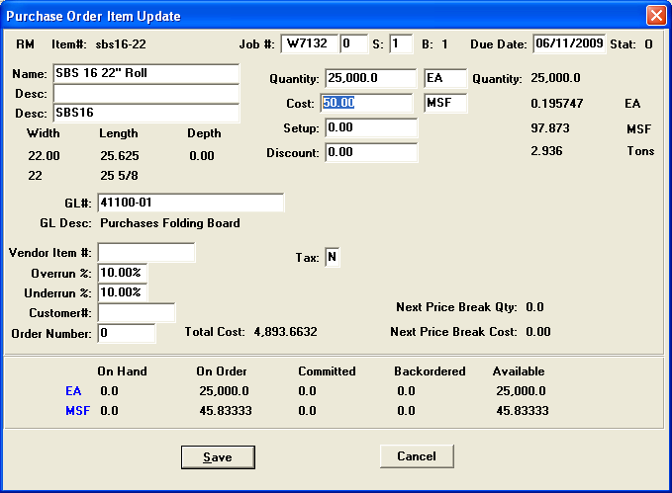

**ESTIMATED BOARD STANDARD COST VS REAL BOARD ACTUAL COST OVERVIEW**

The raw material receipt for SBS16-22 Real Board cost is 26,000 sheets /1000 times (sheet width of 22 times sheet length 25.625 / 144) to yield the total 101.788 MSF times $50 per MSF = $5,089.42 which is listed on the receipt screen.

